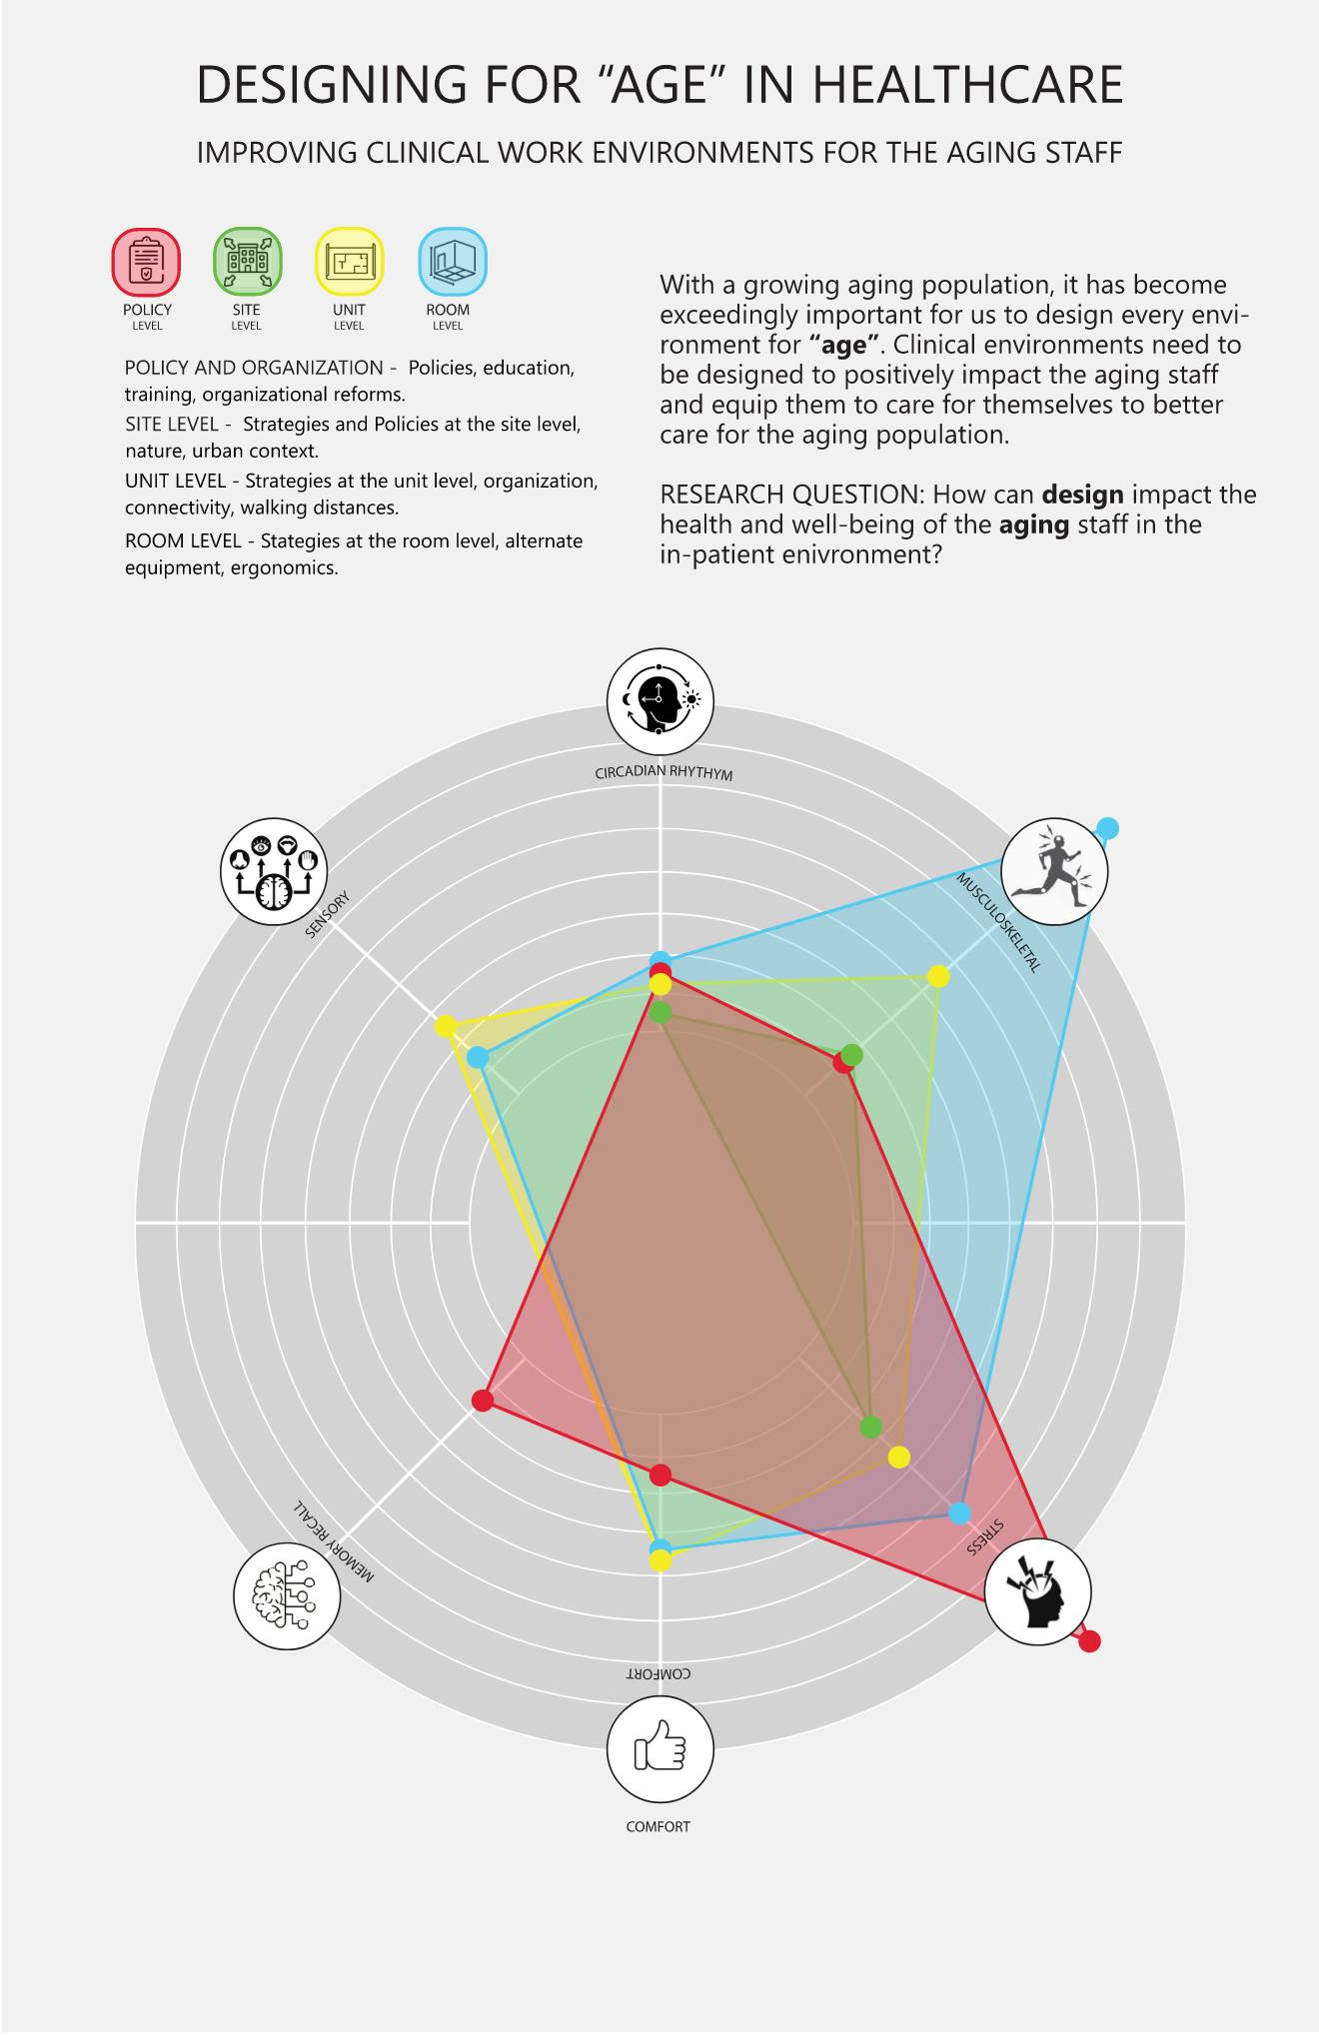
Sharanya Reddy 2022-2023: Improving Clinical Work Environments for the Aging Staff

The gradual increase in the older adult population in the country has resulted in conversations around aging, initiatives, proposals and has established the need for change in our built environments. A survey by The Bureau of Labor Statistics showed that about 58 % of all injuries were a result of the built environment (floors, walkways, surfaces, furniture, fixtures) and caring for the patient (patient transfers, lifting, violence). The current injury rates in conjunction with the growing aging population can have a detrimental effect on the healthcare workforce in the future.
While there is a significant body of research on aging, caring for the elderly patient, design of old age homes, I found it interesting that there is limited research on the needs of the aging staff (nurses, physicians, and doctors) and how the built environment can be an asset to the staff. By examining existing literature, case studies, future trends and interacting with experts in the field, I aim to better understand the aging of human beings, problems associated with every age range, major causes for “Days Away from Work” in the healthcare sector and their relation to the various age groups, aspects of the built environment that further deepen age related health predicaments and conversely how can design alleviate age-related stresses amongst the healthcare workforces. For the purpose of this study, I have chosen to study the inpatient environments and focus on the staff as my key user group.

